Solo USB Personal Audio Player (KA-SBT030)
User Guide
In the box:
- Solo player
- USB C Charger / PSU
- User Guide

6. Charging socket USB C
5. Headphone socket
4. Bluetooth / Playback Status LED
7. Charge status LED

8. Ultrabright Battery Status LEDs
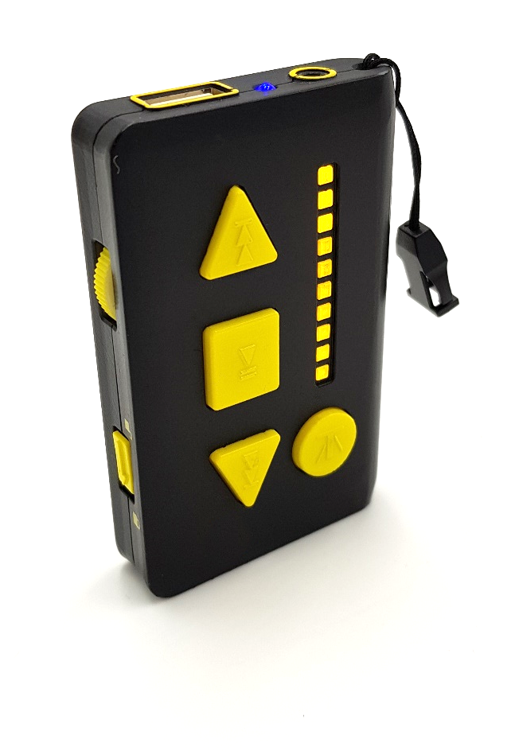
3. USB socket

9. Track back / Fast rewind
2. On / Off / Volume

10. Play / Pause / Battery Status
1. Keypad Lock Control
11. Skip Folder / Re-set
12. Track forward / Fast forward

Introduction:
The Solo has been designed for users who want a high-quality, dedicated, ultra-portable music player

Features:
- High-quality USB audio playback on wired headphones or Bluetooth headphones / speakers.
- Kings famous USB stick book-marking function. The player will always resume at the previous playback point, perfect for audio books. This function works across an unlimited number of memory sticks so allows for multiple books to be enjoyed
- Ultra-portable, pocket sized player (86*55*18mm) with built-in rechargeable Li-ion battery.
- Vibration haptic feedback to confirm Bluetooth pairing status.
- Keypad lock to ensure trouble free pocket usage.
- ‘Click’ on/off/volume control.
- Raised, shaped controls for tactile identification and ease of use.
- Raised port surrounds for tactile identification.
- Real-voice audio announcements of battery level.
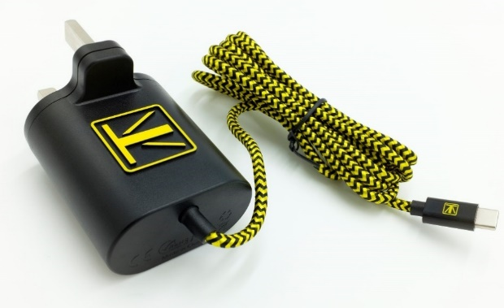
- World’s first Power Supply designed for visually impaired users. We believe our new USB C power supply to be the world’s first designed specifically for visually impaired users. After an extensive consultation period we have designed it with a unique tactile feel, 3D raised logo, high contrast colours and a strengthened braided nylon cable. USB C is a universal standard and will prevent ‘wrong’ chargers being used and potentially damaging equipment.
- Our best ever sound quality. We know when audio is your only interface sound quality matters. Whilst proud of our best-in-class sound quality we are always looking to improve. The solo has the latest generation of digital amplifiers providing clearer sound, less distortion and a louder, clearer head-phone output.
- Optimised USB stick compatibility. We work in an ever-evolving environment for memory chip design which has led to some compatibility challenges as new generations of technology come on-line. We have updated our USB micro-processor to optimise compatibility across the thousands of different USB controller types. We have also refined our unique book-marking process to ensure we can continue to provide this invaluable function.

Functions:
- Audio playback of MP3 and .WAV formatted audio files
- Automatic bookmarking of USB sticks
- Navigation of files and folders
- Bluetooth Transmitter (TX) able to drive Bluetooth headphones and speakers
- Built-in Li-ion battery with 3-8hrs playback per charge (3-4.5hrs on Bluetooth and 3-8hrs on wired headphones)
- Charging via USB C socket
- Real-voice audio battery level announcements and visual level indication via 10 ultra-bright LED’s
- Automatic playback resumption when powering on
- Intelligent and simplified Bluetooth pairing and switching
- Bluetooth 4.2 chipset

CAUTION: Listening at a high volume for a long time may damage your hearing

Over time the sounds from your headphones cause the hair cells in the cochlea to bend down too much or too severely. Even listening to headphones or earbuds at a moderate volume can damage your hearing over time.

The Solo has been designed to allow for a wide range of headphones and for people that may be hard of hearing. It can generate high volume on some headphones so you must always exercise caution when listening.

- Keypad Lock control
Slide down towards the bottom of the player to lock the keypad. This is to avoid unwanted button presses when your Solo is in you pocket.

- On / Off / Volume wheel
Rotate down to switch on and increase volume. Rotate in the opposite direction to reduce volume and switch off. A click is heard and felt when switching on and off. NB sometimes there is a short delay between turning the wheel and the volume changing, this is normal.

- USB A socket
Insert your USB stick into the port

- Status LED
Red flashing – Playback
Red solid – Playback paused or no USB stick present
Blue slow flash – attempting to pair with previous Bluetooth connection
Blue fast flash – attempting new Bluetooth connection

- Headphone Socket (round)
Use headphones with a mini-jack (3.5mm) connector
- USB C Power / Charger socket

- Charge Status LED (yellow)
When you connect the charger the LED will illuminate. When the Solo is fully charged the LED will go out.
- Battery Status LED’s
The 10 LED’s provide a visual indication of remaining charge. Each LED represents (approximately) 10% of charge level so 5 LED’s illuminated = 50% remaining charge. The LED’s automatically illuminate when switching on the unit.

- Track Back / Rewind button*
Short press - skip back a track
Press and hold - Audio rewind within the current track.

- Play / Pause / Battery Status button
Short press – toggle between Play and Pause
Long press (3 seconds) - audio (headphones) and visual (LED’s) battery status report

- Skip Folder (book) / /Re-set button
Short press – Skip to next folder (book)
Long press - Re-set to start of the disk (first folder, first track)
- Track Forward / Fast-Forward button*
Short press - skip forward track
Press and hold - Audio forward within the current track.

- * Manually Trigger Bluetooth reset and attempt new Pairing
Press both Track Forward and Track buttons at the same time for 3 seconds to re-set the Bluetooth and the Solo will automatically seek a new pairing.

Connecting Headphones – wired
Plug in your headphones to the 3.5mm headphone socket

Connecting Headphones (or speaker) via Bluetooth
Whilst there are many different types of Bluetooth devices we have tried to simplify the process as much as possible.
Bluetooth is automatically enabled whenever the Solo is switched on and no wired headphones are connected. When wired headphones are connected Bluetooth is disabled.
The Solo will remember its last paired device and will always try to reconnect to this device when powering on.
To connect to a Bluetooth device for the first time (Headphones or Speaker):
- Please ensure:
  - The Solo is placed within 1 meter (3 feet) of the Bluetooth device you are connecting to.
  - The Bluetooth device and the Solo are both fully charged.
  - The operating instructions of the Bluetooth device are on hand.
  - Where possible switch off Bluetooth on any other nearby devices.

- Switch on the Bluetooth device in pairing mode (usually for headphones this is a long-press of the power button that will often result in a flashing blue or blue/red LED. Please refer to the devices instructions for full details).

- Switch on the Solo and after a couple of seconds press the Track Forward and Track Back buttons together. You will feel 3 short vibrations and the Statas LED will flash rapidly in blue. The Solo is now attempting to pair.
If the pairing is successful The Solo will give one long vibration and playback will start (if a USB stick is inserted). Your Bluetooth device may also inform you of successful connection.
To connect to a previously paired Bluetooth device:
- Switch on the Bluetooth device
- Switch on the Solo
- The Solo will normally re-connect within about 15 seconds and will be confirmed by a single long vibration. Playback will automatically resume.
Bluetooth notes
If the Solo cannot find its previously paired device in 30 seconds it will automatically re-scan to look for a new device to pair with.
If the Solo is paired but looses its connection this will be indicated by 3 short vibrations and rapid blue flashing of the Status LED (as it returns to re-connect mode).
The Solo cannot use Bluetooth and wired headphones simultaneously.

Playing Memory Sticks
Simply insert and switch on. The player will automatically find the audio and start playing. Use the other controls to navigate the audio content.
Bookmarking
The player will automatically remember the last position it played across multiple memory sticks.

Battery and Charging
We recommend your first charge be for 6-8 hours and thereafter charge for 1-2 hours as required. We recommend you do not leave the charger plugged in all the time but if you do please be aware this may reduce the batteries operating life.
To plug in the USBC charger please line-up and carefully insert until it is fully seated.
Caution - minimal force is needed WHEN INSERTING THE USB C CHARGER and excessive force or rough handling may damage the connector and the Solo.
You may operate the Solo whilst the charger is connected but this may reduce the batteries operating life.

USB C Charger / PSU
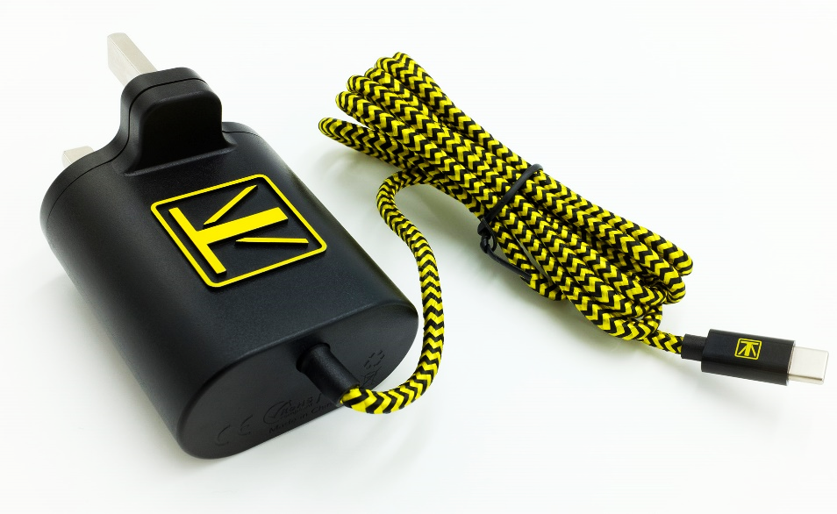
Strong, captive, braided nylon, high contrast cable
Raised 3D ‘K’ logo for tactile identification

USB C connector

Your Solo is supplied with our latest generation USB C Charger / PSU.
This Charger / PSU has been designed for ease of use and handling with the following features:

- 3D tactile design for ease of identification and handling

- USB C connector which is both reversable and compatible with other USB C devices

- High contrast design, strengthened, woven cable

General Safety
Do not allow this product to be exposed to liquids, steam or sand.
Do not store this product in an airtight container or bag as this may lead to deterioration of the rubberised finish.
Do not leave where excessive heat can occur such as in a vehicle, in direct sunlight, on top of a heater or other heat sources.
Do not attempt to open or dismantle any part of this product.
There are no user-serviceable parts inside.
If any faults are discovered do not operate, disconnect from the mains and contact your point of purchase.
EU and BS Declaration of Conformity
This product has been designed, tested and certified to meet the following standards:
Radio Equipment Directive 2014/53/EU
ETSI EN 300 328 v2.1.1(2016-11)
Draft ETSI EN 301 489-1 V2.2.0(2017-03)
Draft ETSI EN 301 489-1 V3.2.0(2017-03)
EN 62479: 2010
EN 60065:2014
EMC Directive - 2014/30/EU
EN 55032:2015
EN 55020:2007+A11:2011+A12:2016
EN 6100-3-2:2014
EN 6100-3-2:2013
BS 1363-1:2016+A1;2018
Bluetooth
Bluetooth: 4.2 Dual mode
2402-2480MHz, OP MAX 1.2dBm
Disposal and Recycling
This product contains a Lithium battery and must be disposed of / recycled with an appropriate agency.
Do not put in general waste.

About Kings Access Technology Ltd:
Founded in 1989 Kings are a leading manufacturer and provider of accessible technology.
Our ethos is based on; accessibility for all, built for purpose (not ‘adapted’), high quality, great design, great value and great customer service.
Whilst our products are centred around the Visually Impaired community they are relevant for multiple sectors including; senior citizens, people living with Alzheimer's, Parkinson's, dementia, autism, reduced motor-function or other access challenges. Our products are also popular with customers who just appreciate simplicity and great design.
All of our products are proudly designed and developed in the United Kingdom.

